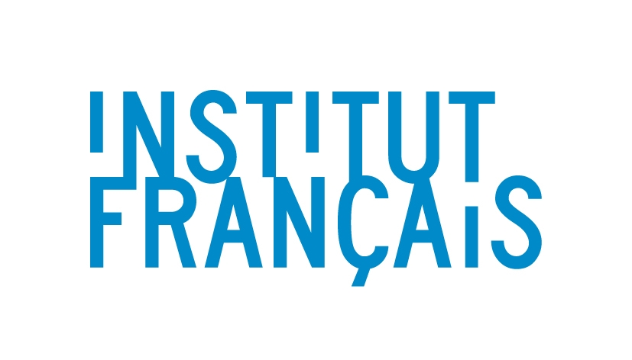

Korea-France Connection 2014

Application (for Korean performing arts professionals)

Name
Job Title
Organisation
Address
Telephone No.
Mobile No.
Email address

Please provide the following details:

- A short biography (maximum 500 words)
- A track record (at least 5 years) of developing international collaborative projects (max 500 words)
- Purpose of participation in the research. Please tell us about your long-term plans and the ability to take forward initiatives within your own organisations (max 500 words)

